Siddhi Gosavi

**23060641017**

**Multivariate Statistical Analysis**

1. Write R code for a principle component analysis.

**CODE:**

install.packages("corrr")

library('corrr')

install.packages("ggcorrplot")

library(ggcorrplot)

install.packages("FactoMineR")

library("FactoMineR")

install.packages("factoextra")

library("factoextra")

wine_quality <- read.csv("D:/MSc Notes/winequality (2).csv")

str(wine_quality)

colSums(is.na(wine_quality))

str(wine_quality)

colSums(is.na(wine_quality))

numerical_data <- wine_quality[,2:10]

head(numerical_data)

data_normalized <- scale(numerical_data)

head(data_normalized)

corr_matrix <- cor(data_normalized)

ggcorrplot(corr_matrix)

data.pca <- princomp(corr_matrix)

summary(data.pca)

data.pca$loadings[, 1:2]

fviz_eig(data.pca, addlabels = TRUE)

# Graph of the variables

fviz_pca_var(data.pca, col.var = "blue")

fviz_cos2(data.pca, choice = "var", axes = 1:2)

fviz_pca_var(data.pca, col.var = "cos2",

gradient.cols = c("blue", "orange", "green"),

repel = TRUE)

**OUTPUT:**

wine_quality <- read.csv("D:/MSc Notes/winequality (2).csv")

> str(wine_quality)

'data.frame': 1599 obs. of 12 variables:

$ fixed.acidity : num 7.4 7.8 7.8 11.2 7.4 7.4 7.9 7.3 7.8 7.5 ...

$ volatile.acidity : num 0.7 0.88 0.76 0.28 0.7 0.66 0.6 0.65 0.58 0.5 ...

$ citric.acid : num 0 0 0.04 0.56 0 0 0.06 0 0.02 0.36 ...

$ residual.sugar : num 1.9 2.6 2.3 1.9 1.9 1.8 1.6 1.2 2 6.1 ...

$ chlorides : num 0.076 0.098 0.092 0.075 0.076 0.075 0.069 0.065 0.073 0.071 ...

$ free.sulfur.dioxide : num 11 25 15 17 11 13 15 15 9 17 ...

$ total.sulfur.dioxide: num 34 67 54 60 34 40 59 21 18 102 ...

$ density : num 0.998 0.997 0.997 0.998 0.998 ...

$ pH : num 3.51 3.2 3.26 3.16 3.51 3.51 3.3 3.39 3.36 3.35 ...

$ sulphates : num 0.56 0.68 0.65 0.58 0.56 0.56 0.46 0.47 0.57 0.8 ...

$ alcohol : num 9.4 9.8 9.8 9.8 9.4 9.4 9.4 10 9.5 10.5 ...

$ quality : int 5 5 5 6 5 5 5 7 7 5 ...

> colSums(is.na(wine_quality))

fixed.acidity volatile.acidity citric.acid residual.sugar

0 0 0 0

chlorides free.sulfur.dioxide total.sulfur.dioxide density

0 0 0 0

pH sulphates alcohol quality

0 0 0 0

> str(wine_quality)

'data.frame': 1599 obs. of 12 variables:

$ fixed.acidity : num 7.4 7.8 7.8 11.2 7.4 7.4 7.9 7.3 7.8 7.5 ...

$ volatile.acidity : num 0.7 0.88 0.76 0.28 0.7 0.66 0.6 0.65 0.58 0.5 ...

$ citric.acid : num 0 0 0.04 0.56 0 0 0.06 0 0.02 0.36 ...

$ residual.sugar : num 1.9 2.6 2.3 1.9 1.9 1.8 1.6 1.2 2 6.1 ...

$ chlorides : num 0.076 0.098 0.092 0.075 0.076 0.075 0.069 0.065 0.073 0.071 ...

$ free.sulfur.dioxide : num 11 25 15 17 11 13 15 15 9 17 ...

$ total.sulfur.dioxide: num 34 67 54 60 34 40 59 21 18 102 ...

$ density : num 0.998 0.997 0.997 0.998 0.998 ...

$ pH : num 3.51 3.2 3.26 3.16 3.51 3.51 3.3 3.39 3.36 3.35 ...

$ sulphates : num 0.56 0.68 0.65 0.58 0.56 0.56 0.46 0.47 0.57 0.8 ...

$ alcohol : num 9.4 9.8 9.8 9.8 9.4 9.4 9.4 10 9.5 10.5 ...

$ quality : int 5 5 5 6 5 5 5 7 7 5 ...

> colSums(is.na(wine_quality))

fixed.acidity volatile.acidity citric.acid residual.sugar

0 0 0 0

chlorides free.sulfur.dioxide total.sulfur.dioxide density

0 0 0 0

pH sulphates alcohol quality

0 0 0 0

> numerical_data <- wine_quality[,2:10]

> head(numerical_data)

volatile.acidity citric.acid residual.sugar chlorides free.sulfur.dioxide

1 0.70 0.00 1.9 0.076 11

2 0.88 0.00 2.6 0.098 25

3 0.76 0.04 2.3 0.092 15

4 0.28 0.56 1.9 0.075 17

5 0.70 0.00 1.9 0.076 11

6 0.66 0.00 1.8 0.075 13

total.sulfur.dioxide density pH sulphates

1 34 0.9978 3.51 0.56

2 67 0.9968 3.20 0.68

3 54 0.9970 3.26 0.65

4 60 0.9980 3.16 0.58

5 34 0.9978 3.51 0.56

6 40 0.9978 3.51 0.56

> data_normalized <- scale(numerical_data)

> head(data_normalized)

volatile.acidity citric.acid residual.sugar chlorides free.sulfur.dioxide

[1,] 0.9615758 -1.391037 -0.45307667 -0.24363047 -0.46604672

[2,] 1.9668271 -1.391037 0.04340257 0.22380518 0.87236532

[3,] 1.2966596 -1.185699 -0.16937425 0.09632273 -0.08364328

[4,] -1.3840105 1.483689 -0.45307667 -0.26487754 0.10755844

[5,] 0.9615758 -1.391037 -0.45307667 -0.24363047 -0.46604672

[6,] 0.7381867 -1.391037 -0.52400227 -0.26487754 -0.27484500

total.sulfur.dioxide density pH sulphates

[1,] -0.3790141 0.55809987 1.2882399 -0.57902538

[2,] 0.6241680 0.02825193 -0.7197081 0.12891007

[3,] 0.2289750 0.13422152 -0.3310730 -0.04807379

[4,] 0.4113718 0.66406945 -0.9787982 -0.46103614

[5,] -0.3790141 0.55809987 1.2882399 -0.57902538

[6,] -0.1966174 0.55809987 1.2882399 -0.57902538

> corr_matrix <- cor(data_normalized)

> ggcorrplot(corr_matrix)

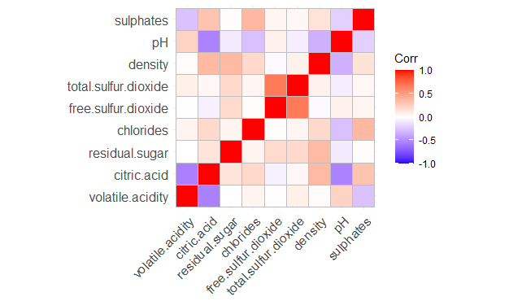

> data.pca <- princomp(corr_matrix)

> summary(data.pca)

Importance of components:

Comp.1 Comp.2 Comp.3 Comp.4 Comp.5 Comp.6

Standard deviation 0.7763802 0.4887568 0.3950594 0.33222983 0.21894505 0.18230599

Proportion of Variance 0.4948076 0.1960980 0.1281186 0.09060763 0.03935118 0.02728283

Cumulative Proportion 0.4948076 0.6909056 0.8190242 0.90963188 0.94898306 0.97626589

Comp.7 Comp.8 Comp.9

Standard deviation 0.13891426 0.098057720 4.916603e-09

Proportion of Variance 0.01584095 0.007893164 1.984348e-17

Cumulative Proportion 0.99210684 1.000000000 1.000000e+00

> data.pca$loadings[, 1:2]

Comp.1 Comp.2

volatile.acidity 0.39651444 0.21477146

citric.acid -0.55384419 -0.08627118

residual.sugar -0.09831135 -0.20600508

chlorides -0.24754177 0.21241897

free.sulfur.dioxide 0.11737166 -0.65258680

total.sulfur.dioxide 0.05848430 -0.63887654

density -0.31157110 0.05383779

pH 0.49320773 0.11938001

sulphates -0.32796941 0.08767969

> fviz_eig(data.pca, addlabels = TRUE)

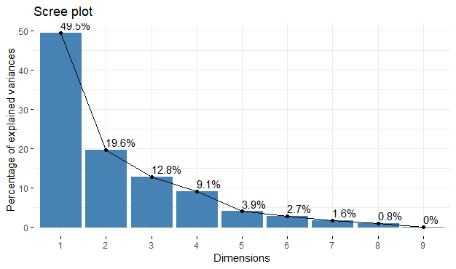

> # Graph of the variables

> fviz_pca_var(data.pca, col.var = "blue")

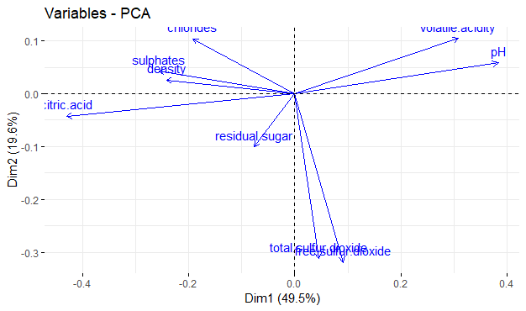

> fviz_cos2(data.pca, choice = "var", axes = 1:2)

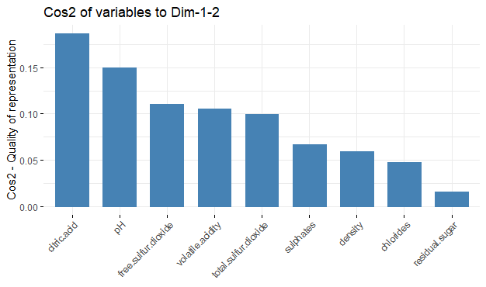

> fviz_pca_var(data.pca, col.var = "cos2",

+ gradient.cols = c("blue", "orange", "green"),

+ repel = TRUE)

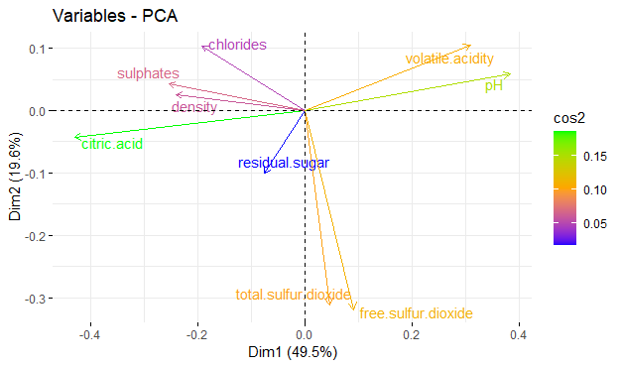

2. Write R code for factor analysis

**Code:**

**factor_analysis <- factanal(numerical_data, factors = 3)**

**print(factor_analysis)**

**OUTPUT:**

> factor_analysis <- factanal(numerical_data, factors = 3)

> print(factor_analysis)

Call:

factanal(x = numerical_data, factors = 3)

Uniquenesses:

volatile.acidity citric.acid residual.sugar chlorides

0.005 0.290 0.884 0.827

free.sulfur.dioxide total.sulfur.dioxide density pH

0.039 0.496 0.646 0.559

sulphates

0.843

Loadings:

Factor1 Factor2 Factor3

volatile.acidity 0.992

citric.acid -0.611 0.580

residual.sugar 0.216 0.262

chlorides 0.413

free.sulfur.dioxide 0.976

total.sulfur.dioxide 0.697 0.128

density 0.593

pH 0.293 -0.596

sulphates -0.290 0.262

Factor1 Factor2 Factor3

SS loadings 1.533 1.495 1.385

Proportion Var 0.170 0.166 0.154

Cumulative Var 0.170 0.336 0.490

Test of the hypothesis that 3 factors are sufficient.

The chi square statistic is 355.35 on 12 degrees of freedom.

The p-value is 1.04e-68

3.Write R code for canonical correleation analysis.

**Code:**

attach(wine_quality)

# Making two vectors X and Y

X<-wine_quality[1:6]

Y<-wine_quality[7:13]

print(X)

print(Y)

#Perform Canonical Correlation Analysis

cca_result <- cancor(X, Y)

# Summary of the results

summary(cca_result)

# Canonical Correlation Coefficients

cca_result$cor

# Canonical Loadings for X

cca_result$xcoef

# Canonical Loadings for Y

cca_result$ycoef

**INPUT:**

> attach(wine_quality)

> # Making two vectors X and Y

> X<-wine_quality[1:6]

> Y<-wine_quality[7:13]

Error in `[.data.frame`(wine_quality, 7:13) : undefined columns selected

> attach(wine_quality)

The following objects are masked from wine_quality (pos = 3):

alcohol, chlorides, citric.acid, density, fixed.acidity,

free.sulfur.dioxide, pH, quality, residual.sugar, sulphates,

total.sulfur.dioxide, volatile.acidity

> # Making two vectors X and Y

> X<-wine_quality[1:6]

> Y<-wine_quality[7:13]

Error in `[.data.frame`(wine_quality, 7:13) : undefined columns selected

> attach(wine_quality)

The following objects are masked from wine_quality (pos = 3):

alcohol, chlorides, citric.acid, density, fixed.acidity,

free.sulfur.dioxide, pH, quality, residual.sugar, sulphates,

total.sulfur.dioxide, volatile.acidity

The following objects are masked from wine_quality (pos = 4):

alcohol, chlorides, citric.acid, density, fixed.acidity,

free.sulfur.dioxide, pH, quality, residual.sugar, sulphates,

total.sulfur.dioxide, volatile.acidity

> # Making two vectors X and Y

> X<-wine_quality[1:6]

> Y<-wine_quality[7:12]

> print(X)

fixed.acidity volatile.acidity citric.acid residual.sugar chlorides

1 7.4 0.700 0.00 1.90 0.076

2 7.8 0.880 0.00 2.60 0.098

3 7.8 0.760 0.04 2.30 0.092

4 11.2 0.280 0.56 1.90 0.075

5 7.4 0.700 0.00 1.90 0.076

6 7.4 0.660 0.00 1.80 0.075

7 7.9 0.600 0.06 1.60 0.069

8 7.3 0.650 0.00 1.20 0.065

9 7.8 0.580 0.02 2.00 0.073

10 7.5 0.500 0.36 6.10 0.071

11 6.7 0.580 0.08 1.80 0.097

12 7.5 0.500 0.36 6.10 0.071

13 5.6 0.615 0.00 1.60 0.089

14 7.8 0.610 0.29 1.60 0.114

15 8.9 0.620 0.18 3.80 0.176

16 8.9 0.620 0.19 3.90 0.170

17 8.5 0.280 0.56 1.80 0.092

18 8.1 0.560 0.28 1.70 0.368

19 7.4 0.590 0.08 4.40 0.086

20 7.9 0.320 0.51 1.80 0.341

21 8.9 0.220 0.48 1.80 0.077

22 7.6 0.390 0.31 2.30 0.082

23 7.9 0.430 0.21 1.60 0.106

24 8.5 0.490 0.11 2.30 0.084

25 6.9 0.400 0.14 2.40 0.085

26 6.3 0.390 0.16 1.40 0.080

27 7.6 0.410 0.24 1.80 0.080

28 7.9 0.430 0.21 1.60 0.106

29 7.1 0.710 0.00 1.90 0.080

30 7.8 0.645 0.00 2.00 0.082

31 6.7 0.675 0.07 2.40 0.089

32 6.9 0.685 0.00 2.50 0.105

33 8.3 0.655 0.12 2.30 0.083

34 6.9 0.605 0.12 10.70 0.073

35 5.2 0.320 0.25 1.80 0.103

36 7.8 0.645 0.00 5.50 0.086

37 7.8 0.600 0.14 2.40 0.086

38 8.1 0.380 0.28 2.10 0.066

39 5.7 1.130 0.09 1.50 0.172

40 7.3 0.450 0.36 5.90 0.074

41 7.3 0.450 0.36 5.90 0.074

42 8.8 0.610 0.30 2.80 0.088

43 7.5 0.490 0.20 2.60 0.332

44 8.1 0.660 0.22 2.20 0.069

45 6.8 0.670 0.02 1.80 0.050

46 4.6 0.520 0.15 2.10 0.054

47 7.7 0.935 0.43 2.20 0.114

48 8.7 0.290 0.52 1.60 0.113

49 6.4 0.400 0.23 1.60 0.066

50 5.6 0.310 0.37 1.40 0.074

51 8.8 0.660 0.26 1.70 0.074

52 6.6 0.520 0.04 2.20 0.069

53 6.6 0.500 0.04 2.10 0.068

54 8.6 0.380 0.36 3.00 0.081

55 7.6 0.510 0.15 2.80 0.110

56 7.7 0.620 0.04 3.80 0.084

57 10.2 0.420 0.57 3.40 0.070

58 7.5 0.630 0.12 5.10 0.111

59 7.8 0.590 0.18 2.30 0.076

60 7.3 0.390 0.31 2.40 0.074

61 8.8 0.400 0.40 2.20 0.079

62 7.7 0.690 0.49 1.80 0.115

63 7.5 0.520 0.16 1.90 0.085

64 7.0 0.735 0.05 2.00 0.081

65 7.2 0.725 0.05 4.65 0.086

66 7.2 0.725 0.05 4.65 0.086

67 7.5 0.520 0.11 1.50 0.079

68 6.6 0.705 0.07 1.60 0.076

69 9.3 0.320 0.57 2.00 0.074

70 8.0 0.705 0.05 1.90 0.074

71 7.7 0.630 0.08 1.90 0.076

72 7.7 0.670 0.23 2.10 0.088

73 7.7 0.690 0.22 1.90 0.084

74 8.3 0.675 0.26 2.10 0.084

75 9.7 0.320 0.54 2.50 0.094

76 8.8 0.410 0.64 2.20 0.093

77 8.8 0.410 0.64 2.20 0.093

78 6.8 0.785 0.00 2.40 0.104

79 6.7 0.750 0.12 2.00 0.086

80 8.3 0.625 0.20 1.50 0.080

81 6.2 0.450 0.20 1.60 0.069

82 7.8 0.430 0.70 1.90 0.464

83 7.4 0.500 0.47 2.00 0.086

84 7.3 0.670 0.26 1.80 0.401

85 6.3 0.300 0.48 1.80 0.069

86 6.9 0.550 0.15 2.20 0.076

87 8.6 0.490 0.28 1.90 0.110

88 7.7 0.490 0.26 1.90 0.062

89 9.3 0.390 0.44 2.10 0.107

90 7.0 0.620 0.08 1.80 0.076

91 7.9 0.520 0.26 1.90 0.079

92 8.6 0.490 0.28 1.90 0.110

93 8.6 0.490 0.29 2.00 0.110

94 7.7 0.490 0.26 1.90 0.062

95 5.0 1.020 0.04 1.40 0.045

96 4.7 0.600 0.17 2.30 0.058

97 6.8 0.775 0.00 3.00 0.102

98 7.0 0.500 0.25 2.00 0.070

99 7.6 0.900 0.06 2.50 0.079

100 8.1 0.545 0.18 1.90 0.080

101 8.3 0.610 0.30 2.10 0.084

102 7.8 0.500 0.30 1.90 0.075

103 8.1 0.545 0.18 1.90 0.080

104 8.1 0.575 0.22 2.10 0.077

105 7.2 0.490 0.24 2.20 0.070

106 8.1 0.575 0.22 2.10 0.077

107 7.8 0.410 0.68 1.70 0.467

108 6.2 0.630 0.31 1.70 0.088

109 8.0 0.330 0.53 2.50 0.091

110 8.1 0.785 0.52 2.00 0.122

111 7.8 0.560 0.19 1.80 0.104

112 8.4 0.620 0.09 2.20 0.084

113 8.4 0.600 0.10 2.20 0.085

114 10.1 0.310 0.44 2.30 0.080

115 7.8 0.560 0.19 1.80 0.104

116 9.4 0.400 0.31 2.20 0.090

117 8.3 0.540 0.28 1.90 0.077

118 7.8 0.560 0.12 2.00 0.082

119 8.8 0.550 0.04 2.20 0.119

120 7.0 0.690 0.08 1.80 0.097

121 7.3 1.070 0.09 1.70 0.178

122 8.8 0.550 0.04 2.20 0.119

123 7.3 0.695 0.00 2.50 0.075

124 8.0 0.710 0.00 2.60 0.080

125 7.8 0.500 0.17 1.60 0.082

126 9.0 0.620 0.04 1.90 0.146

127 8.2 1.330 0.00 1.70 0.081

128 8.1 1.330 0.00 1.80 0.082

129 8.0 0.590 0.16 1.80 0.065

130 6.1 0.380 0.15 1.80 0.072

131 8.0 0.745 0.56 2.00 0.118

132 5.6 0.500 0.09 2.30 0.049

133 5.6 0.500 0.09 2.30 0.049

134 6.6 0.500 0.01 1.50 0.060

135 7.9 1.040 0.05 2.20 0.084

136 8.4 0.745 0.11 1.90 0.090

137 8.3 0.715 0.15 1.80 0.089

138 7.2 0.415 0.36 2.00 0.081

139 7.8 0.560 0.19 2.10 0.081

140 7.8 0.560 0.19 2.00 0.081

141 8.4 0.745 0.11 1.90 0.090

142 8.3 0.715 0.15 1.80 0.089

143 5.2 0.340 0.00 1.80 0.050

144 6.3 0.390 0.08 1.70 0.066

145 5.2 0.340 0.00 1.80 0.050

146 8.1 0.670 0.55 1.80 0.117

147 5.8 0.680 0.02 1.80 0.087

148 7.6 0.490 0.26 1.60 0.236

149 6.9 0.490 0.10 2.30 0.074

150 8.2 0.400 0.44 2.80 0.089

151 7.3 0.330 0.47 2.10 0.077

152 9.2 0.520 1.00 3.40 0.610

153 7.5 0.600 0.03 1.80 0.095

154 7.5 0.600 0.03 1.80 0.095

155 7.1 0.430 0.42 5.50 0.070

156 7.1 0.430 0.42 5.50 0.071

157 7.1 0.430 0.42 5.50 0.070

158 7.1 0.430 0.42 5.50 0.071

159 7.1 0.680 0.00 2.20 0.073

160 6.8 0.600 0.18 1.90 0.079

161 7.6 0.950 0.03 2.00 0.090

162 7.6 0.680 0.02 1.30 0.072

163 7.8 0.530 0.04 1.70 0.076

164 7.4 0.600 0.26 7.30 0.070

165 7.3 0.590 0.26 7.20 0.070

166 7.8 0.630 0.48 1.70 0.100

free.sulfur.dioxide

1 11

2 25

3 15

4 17

5 11

6 13

7 15

8 15

9 9

10 17

11 15

12 17

13 16

14 9

15 52

16 51

17 35

18 16

19 6

20 17

21 29

22 23

23 10

24 9

25 21

26 11

27 4

28 10

29 14

30 8

31 17

32 22

33 15

34 40

35 13

36 5

37 3

38 13

39 7

40 12

41 12

42 17

43 8

44 9

45 5

46 8

47 22

48 12

49 5

50 12

51 4

52 8

53 6

54 30

55 33

56 25

57 4

58 50

59 17

60 9

61 19

62 20

63 12

64 13

65 4

66 4

67 11

68 6

69 27

70 8

71 15

72 17

73 18

74 11

75 28

76 9

77 9

78 14

79 12

80 27

81 3

82 22

83 21

84 16

85 18

86 19

87 20

88 9

89 34

90 8

91 42

92 20

93 19

94 9

95 41

96 17

97 8

98 3

99 5

100 13

101 11

102 8

103 13

104 12

105 5

106 12

107 18

108 15

109 18

110 37

111 12

112 11

113 14

114 22

115 12

116 13

117 11

118 7

119 14

120 22

121 10

122 14

123 3

124 11

125 21

126 27

127 3

128 3

129 3

130 6

131 30

132 17

133 17

134 17

135 13

136 16

137 10

138 13

139 15

140 17

141 16

142 10

143 27

144 3

145 27

146 32

147 21

148 10

149 12

150 11

151 5

152 32

153 25

154 25

155 29

156 28

157 29

158 28

159 12

160 18

161 7

162 9

163 17

164 36

165 35

166 14

[ reached 'max' / getOption("max.print") -- omitted 1433 rows ]

> print(Y)

total.sulfur.dioxide density pH sulphates alcohol quality

1 34 0.9978 3.51 0.56 9.4 5

2 67 0.9968 3.20 0.68 9.8 5

3 54 0.9970 3.26 0.65 9.8 5

4 60 0.9980 3.16 0.58 9.8 6

5 34 0.9978 3.51 0.56 9.4 5

6 40 0.9978 3.51 0.56 9.4 5

7 59 0.9964 3.30 0.46 9.4 5

8 21 0.9946 3.39 0.47 10.0 7

9 18 0.9968 3.36 0.57 9.5 7

10 102 0.9978 3.35 0.80 10.5 5

11 65 0.9959 3.28 0.54 9.2 5

12 102 0.9978 3.35 0.80 10.5 5

13 59 0.9943 3.58 0.52 9.9 5

14 29 0.9974 3.26 1.56 9.1 5

15 145 0.9986 3.16 0.88 9.2 5

16 148 0.9986 3.17 0.93 9.2 5

17 103 0.9969 3.30 0.75 10.5 7

18 56 0.9968 3.11 1.28 9.3 5

19 29 0.9974 3.38 0.50 9.0 4

20 56 0.9969 3.04 1.08 9.2 6

21 60 0.9968 3.39 0.53 9.4 6

22 71 0.9982 3.52 0.65 9.7 5

23 37 0.9966 3.17 0.91 9.5 5

24 67 0.9968 3.17 0.53 9.4 5

25 40 0.9968 3.43 0.63 9.7 6

26 23 0.9955 3.34 0.56 9.3 5

27 11 0.9962 3.28 0.59 9.5 5

28 37 0.9966 3.17 0.91 9.5 5

29 35 0.9972 3.47 0.55 9.4 5

30 16 0.9964 3.38 0.59 9.8 6

31 82 0.9958 3.35 0.54 10.1 5

32 37 0.9966 3.46 0.57 10.6 6

33 113 0.9966 3.17 0.66 9.8 5

34 83 0.9993 3.45 0.52 9.4 6

35 50 0.9957 3.38 0.55 9.2 5

36 18 0.9986 3.40 0.55 9.6 6

37 15 0.9975 3.42 0.60 10.8 6

38 30 0.9968 3.23 0.73 9.7 7

39 19 0.9940 3.50 0.48 9.8 4

40 87 0.9978 3.33 0.83 10.5 5

41 87 0.9978 3.33 0.83 10.5 5

42 46 0.9976 3.26 0.51 9.3 4

43 14 0.9968 3.21 0.90 10.5 6

44 23 0.9968 3.30 1.20 10.3 5

45 11 0.9962 3.48 0.52 9.5 5

46 65 0.9934 3.90 0.56 13.1 4

47 114 0.9970 3.25 0.73 9.2 5

48 37 0.9969 3.25 0.58 9.5 5

49 12 0.9958 3.34 0.56 9.2 5

50 96 0.9954 3.32 0.58 9.2 5

51 23 0.9971 3.15 0.74 9.2 5

52 15 0.9956 3.40 0.63 9.4 6

53 14 0.9955 3.39 0.64 9.4 6

54 119 0.9970 3.20 0.56 9.4 5

55 73 0.9955 3.17 0.63 10.2 6

56 45 0.9978 3.34 0.53 9.5 5

57 10 0.9971 3.04 0.63 9.6 5

58 110 0.9983 3.26 0.77 9.4 5

59 54 0.9975 3.43 0.59 10.0 5

60 46 0.9962 3.41 0.54 9.4 6

61 52 0.9980 3.44 0.64 9.2 5

62 112 0.9968 3.21 0.71 9.3 5

63 35 0.9968 3.38 0.62 9.5 7

64 54 0.9966 3.39 0.57 9.8 5

65 11 0.9962 3.41 0.39 10.9 5

66 11 0.9962 3.41 0.39 10.9 5

67 39 0.9968 3.42 0.58 9.6 5

68 15 0.9962 3.44 0.58 10.7 5

69 65 0.9969 3.28 0.79 10.7 5

70 19 0.9962 3.34 0.95 10.5 6

71 27 0.9967 3.32 0.54 9.5 6

72 96 0.9962 3.32 0.48 9.5 5

73 94 0.9961 3.31 0.48 9.5 5

74 43 0.9976 3.31 0.53 9.2 4

75 83 0.9984 3.28 0.82 9.6 5

76 42 0.9986 3.54 0.66 10.5 5

77 42 0.9986 3.54 0.66 10.5 5

78 30 0.9966 3.52 0.55 10.7 6

79 80 0.9958 3.38 0.52 10.1 5

80 119 0.9972 3.16 1.12 9.1 4

81 15 0.9958 3.41 0.56 9.2 5

82 67 0.9974 3.13 1.28 9.4 5

83 73 0.9970 3.36 0.57 9.1 5

84 51 0.9969 3.16 1.14 9.4 5

85 61 0.9959 3.44 0.78 10.3 6

86 40 0.9961 3.41 0.59 10.1 5

87 136 0.9972 2.93 1.95 9.9 6

88 31 0.9966 3.39 0.64 9.6 5

89 125 0.9978 3.14 1.22 9.5 5

90 24 0.9978 3.48 0.53 9.0 5

91 140 0.9964 3.23 0.54 9.5 5

92 136 0.9972 2.93 1.95 9.9 6

93 133 0.9972 2.93 1.98 9.8 5

94 31 0.9966 3.39 0.64 9.6 5

95 85 0.9938 3.75 0.48 10.5 4

96 106 0.9932 3.85 0.60 12.9 6

97 23 0.9965 3.45 0.56 10.7 5

98 22 0.9963 3.25 0.63 9.2 5

99 10 0.9967 3.39 0.56 9.8 5

100 35 0.9972 3.30 0.59 9.0 6

101 50 0.9972 3.40 0.61 10.2 6

102 22 0.9959 3.31 0.56 10.4 6

103 35 0.9972 3.30 0.59 9.0 6

104 65 0.9967 3.29 0.51 9.2 5

105 36 0.9960 3.33 0.48 9.4 5

106 65 0.9967 3.29 0.51 9.2 5

107 69 0.9973 3.08 1.31 9.3 5

108 64 0.9969 3.46 0.79 9.3 5

109 80 0.9976 3.37 0.80 9.6 6

110 153 0.9969 3.21 0.69 9.3 5

111 47 0.9964 3.19 0.93 9.5 5

112 108 0.9964 3.15 0.66 9.8 5

113 111 0.9964 3.15 0.66 9.8 5

114 46 0.9988 3.32 0.67 9.7 6

115 47 0.9964 3.19 0.93 9.5 5

116 62 0.9966 3.07 0.63 10.5 6

117 40 0.9978 3.39 0.61 10.0 6

118 28 0.9970 3.37 0.50 9.4 6

119 56 0.9962 3.21 0.60 10.9 6

120 89 0.9959 3.34 0.54 9.2 6

121 89 0.9962 3.30 0.57 9.0 5

122 56 0.9962 3.21 0.60 10.9 6

123 13 0.9980 3.49 0.52 9.2 5

124 34 0.9976 3.44 0.53 9.5 5

125 102 0.9960 3.39 0.48 9.5 5

126 90 0.9984 3.16 0.70 9.4 5

127 12 0.9964 3.53 0.49 10.9 5

128 12 0.9964 3.54 0.48 10.9 5

129 16 0.9962 3.42 0.92 10.5 7

130 19 0.9955 3.42 0.57 9.4 5

131 134 0.9968 3.24 0.66 9.4 5

132 99 0.9937 3.63 0.63 13.0 5

133 99 0.9937 3.63 0.63 13.0 5

134 26 0.9952 3.40 0.58 9.8 6

135 29 0.9959 3.22 0.55 9.9 6

136 63 0.9965 3.19 0.82 9.6 5

137 52 0.9968 3.23 0.77 9.5 5

138 45 0.9972 3.48 0.64 9.2 5

139 105 0.9962 3.33 0.54 9.5 5

140 108 0.9962 3.32 0.54 9.5 5

141 63 0.9965 3.19 0.82 9.6 5

142 52 0.9968 3.23 0.77 9.5 5

143 63 0.9916 3.68 0.79 14.0 6

144 20 0.9954 3.34 0.58 9.4 5

145 63 0.9916 3.68 0.79 14.0 6

146 141 0.9968 3.17 0.62 9.4 5

147 94 0.9944 3.54 0.52 10.0 5

148 88 0.9968 3.11 0.80 9.3 5

149 30 0.9959 3.42 0.58 10.2 6

150 43 0.9975 3.53 0.61 10.5 6

151 11 0.9958 3.33 0.53 10.3 6

152 69 0.9996 2.74 2.00 9.4 4

153 99 0.9950 3.35 0.54 10.1 5

154 99 0.9950 3.35 0.54 10.1 5

155 129 0.9973 3.42 0.72 10.5 5

156 128 0.9973 3.42 0.71 10.5 5

157 129 0.9973 3.42 0.72 10.5 5

158 128 0.9973 3.42 0.71 10.5 5

159 22 0.9969 3.48 0.50 9.3 5

160 86 0.9968 3.59 0.57 9.3 6

161 20 0.9959 3.20 0.56 9.6 5

162 20 0.9965 3.17 1.08 9.2 4

163 31 0.9964 3.33 0.56 10.0 6

164 121 0.9982 3.37 0.49 9.4 5

165 121 0.9981 3.37 0.49 9.4 5

166 96 0.9961 3.19 0.62 9.5 5

[ reached 'max' / getOption("max.print") -- omitted 1433 rows ]

> #Perform Canonical Correlation Analysis

> cca_result <- cancor(X, Y)

> # Summary of the results

> summary(cca_result)

Length Class Mode

cor 6 -none- numeric

xcoef 36 -none- numeric

ycoef 36 -none- numeric

xcenter 6 -none- numeric

ycenter 6 -none- numeric

> # Canonical Correlation Coefficients

> cca_result$cor

[1] 0.9345108 0.7125917 0.5367743 0.4268398 0.1850280 0.1659524

> # Canonical Loadings for X

> cca_result$xcoef

[,1] [,2] [,3] [,4]

fixed.acidity -0.0131007129 -0.002065917 -0.0020145043 -0.0051154043

volatile.acidity -0.0026595090 0.040969341 -0.0597674978 -0.0929292538

citric.acid -0.0002141502 0.058160549 0.0170363227 0.0546435653

residual.sugar -0.0046466691 0.003719081 -0.0080595742 0.0007428169

chlorides -0.0526905389 -0.062448160 0.4145719684 -0.2789677208

free.sulfur.dioxide 0.0001958465 0.002131788 0.0005084632 -0.0001382334

[,5] [,6]

fixed.acidity -0.012905377 5.478320e-03

volatile.acidity 0.042560290 -1.238271e-01

citric.acid 0.112480443 -1.638335e-01

residual.sugar 0.010839773 1.099220e-02

chlorides 0.110895880 2.086209e-01

free.sulfur.dioxide -0.001134881 -8.510995e-07

> # Canonical Loadings for Y

> cca_result$ycoef

[,1] [,2] [,3] [,4]

total.sulfur.dioxide 8.200591e-05 0.0007719184 1.732424e-05 8.063418e-05

density -1.085307e+01 3.3211597995 -8.146686e+00 -1.898735e+00

pH 8.856989e-02 0.0148491977 -5.944438e-02 -2.238442e-02

sulphates 8.401829e-03 -0.0056775702 1.260793e-01 -1.876702e-02

alcohol -1.002391e-02 0.0060564855 -1.148597e-02 9.608252e-03

quality -3.342330e-04 0.0013589772 2.962052e-04 2.234066e-02

[,5] [,6]

total.sulfur.dioxide -8.145362e-05 -4.110437e-05

density 4.707491e+00 6.407521e+00

pH 6.209685e-02 1.237199e-01

sulphates 8.461502e-02 3.939217e-02

alcohol 2.071206e-02 -1.303448e-02

quality -1.993577e-02 2.146963e-02